Final Report: Capstone Project

# Introduction

## To find the most suitable neighbourhood to rent in Bangalore, India

One of my friend is moving from Pune to Bangalore for a new job. He needs help in deciding which neighbourhood to select for renting. The decision will be based on distance from his new office location, his choice of preferred venue categories he would like near his place of stay. Number of venues nearby should also affect his decision.

We would also look at the affordability of the neighbourhoods based on rent data.

In short, we would look at the following 3 factors

1. Proximity to Office
2. Nearby Facilities
3. Affordability

# Data

We'll first take user input of list of venue categories he would like to have near his place of staying.

Then keeping his office location static, call foursquare API to check all the neighbourhoods within 3-4km. For doing this we would need to scrape pin code and locality data from an external link and latitude and longitude data from geopy

<https://www.mapsofindia.com/pincode/india/karnataka/bangalore>

Find all the nearby venues and count them against the user defined categories. Use Euclidean distance for finding the best fit neighbourhoods.

I would also be using the rent data from the following URL, to take into account affordability of the neighbourhood. Avg. rent column from the link would be used to define the rent of the neighbourhood

<https://www.makaan.com/price-trends/property-rates-for-rent-in-bangalore>

From the already shortlisted neighbourhoods, I'll check which one has the least amount of rent.

Priority should be given to proximity (will be taken care by foursquare radius variable), facilities (will be taken care by best fit neighbourhoods), affordability in that order (will be taken care by the rent data)

# Methodology

The whole project can be divided into following points

1. Defined User Preferences

Define different parameters to capture user preferences, like office address, proximity threshold from office, users list of preferred categories, and the weight to be provided for each feature

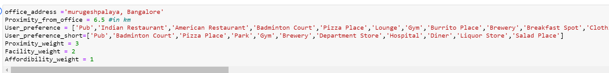

1. Find location of office

Based on the office address, we would first mark the location on the map and would work on all localities taking office address as the center.

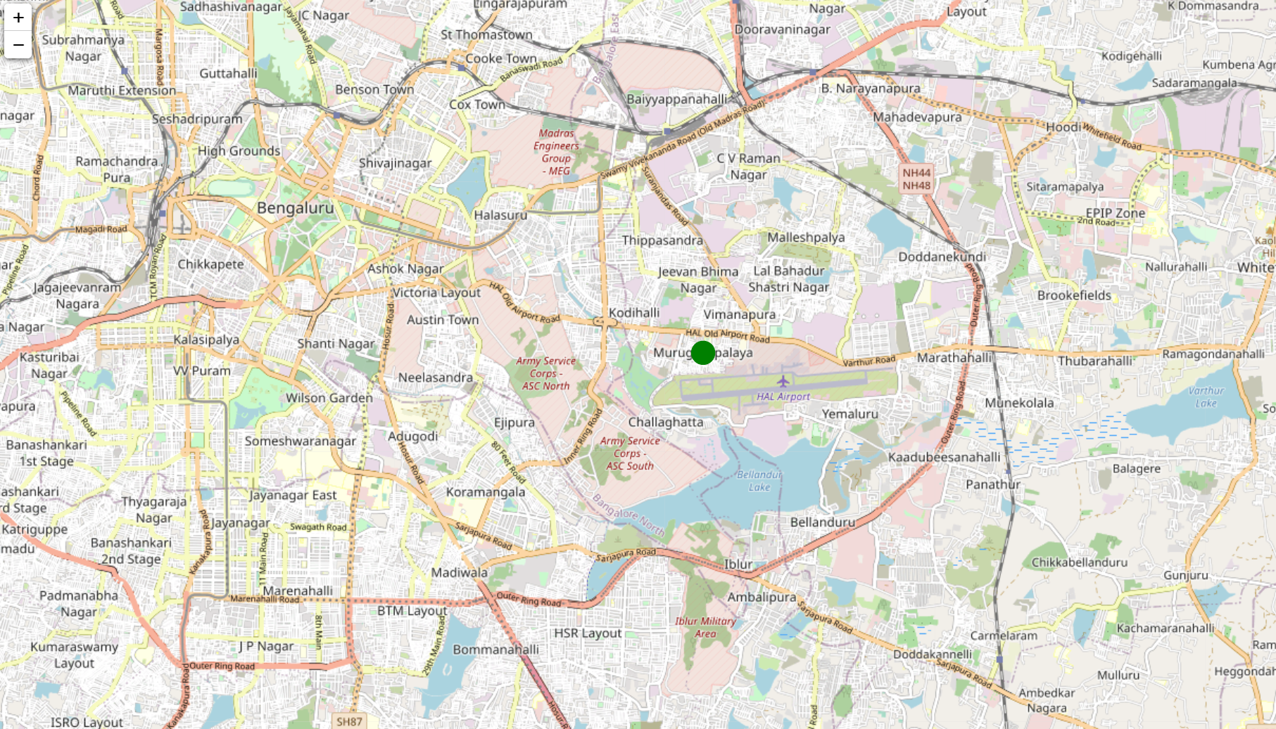

1. Find neighbourhoods close to office

Using external links, we'll first figure out the postal codes and localities in Bnagalore. We'll then use geopy to assign latitudes and longitudes to the localities. We'll then calculate the distance of each locality from the office and filter out those which doesnt satify the distance threshold criteria

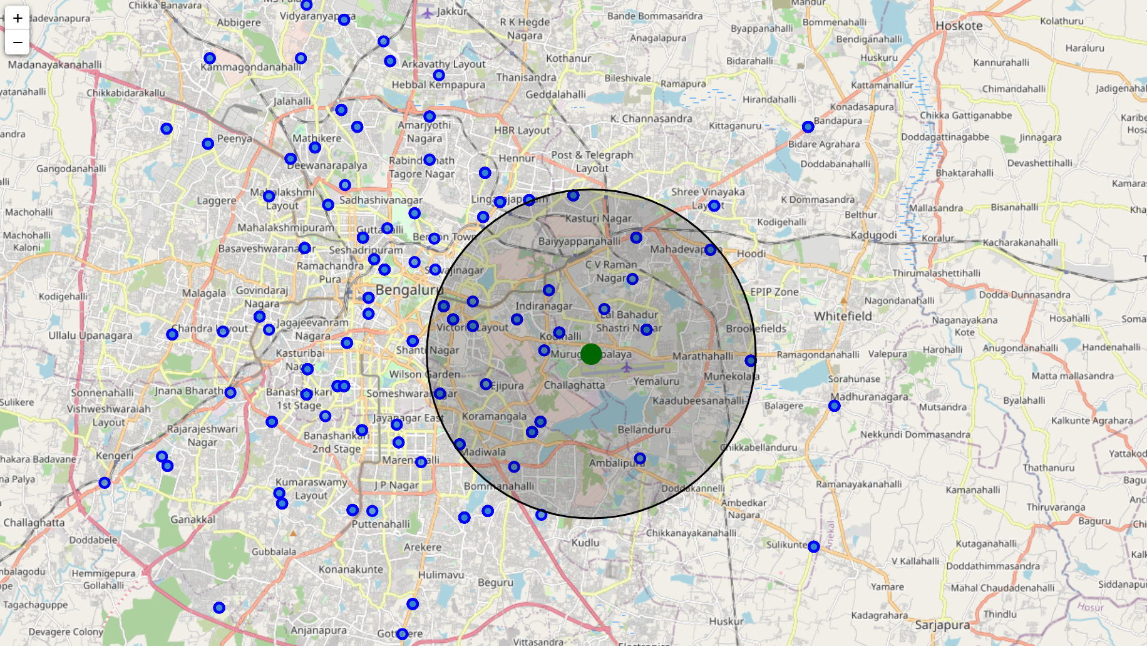

1. Check out venues in those neighbourhoods

Using foursquare API we'll explore all the venues near the filtered localities

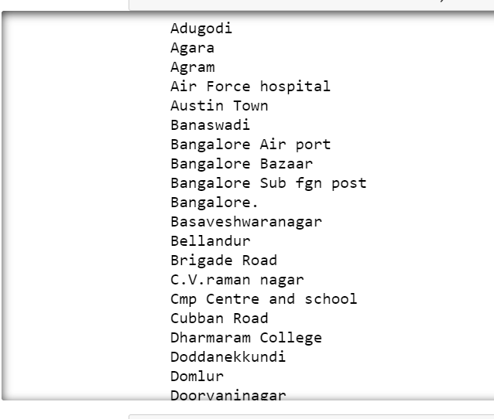

1. Rate venues according to User's Preference List

We'll mark all venues against users preferrence, if venue category is present in user's preference list we'll mark it as one and then aggregate all the records with respect to the locality to get rating for every locality

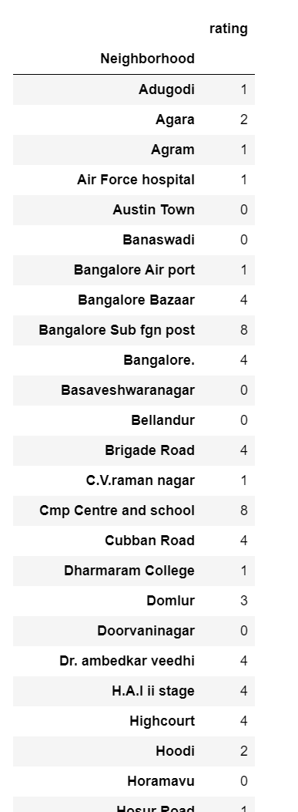

1. Upload rent for different regions

Using external links, we'll create a table to store locality vs rent data for a 2-bhk flat.

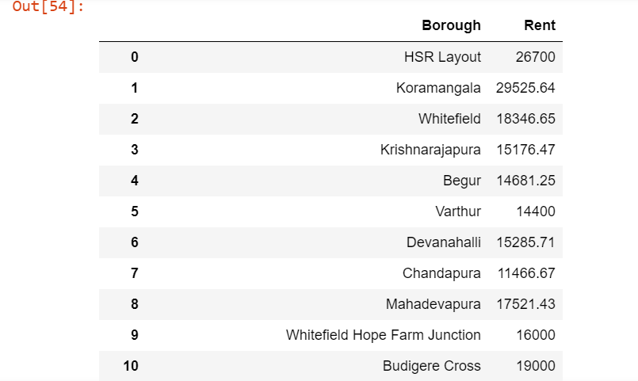

1. Add a distance column and rent column and matching score with user venue preference in a single table

We'll then merge all three parameters in a single table based on the locality

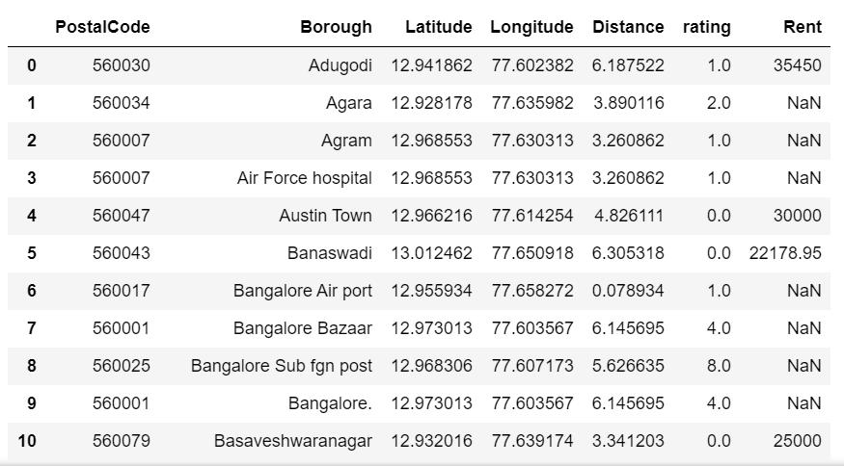

1. Define a metric for ranking

We'll define a new metric for calculating final rating for each locality based on the different weightages as specified by the user.



1. Final Ranking Table

We'll sort the table and select the top candidates based on highest final rating

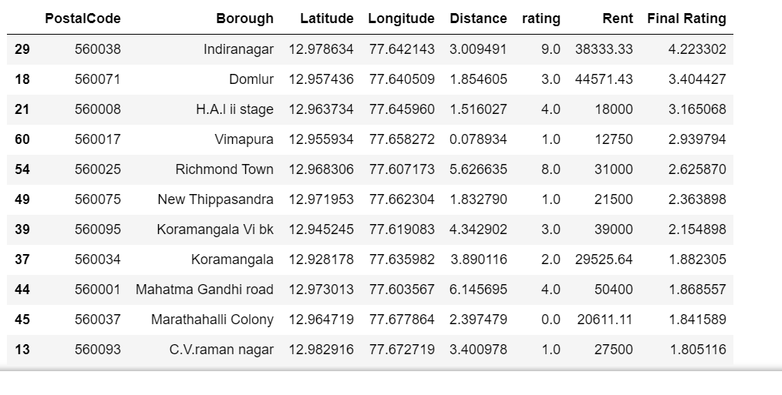

1. Visualize preferred location with final ranking data (radius of circle)

We'll then try to visualize the preferred localities on the map. Most preferred would have the highest radius marker.

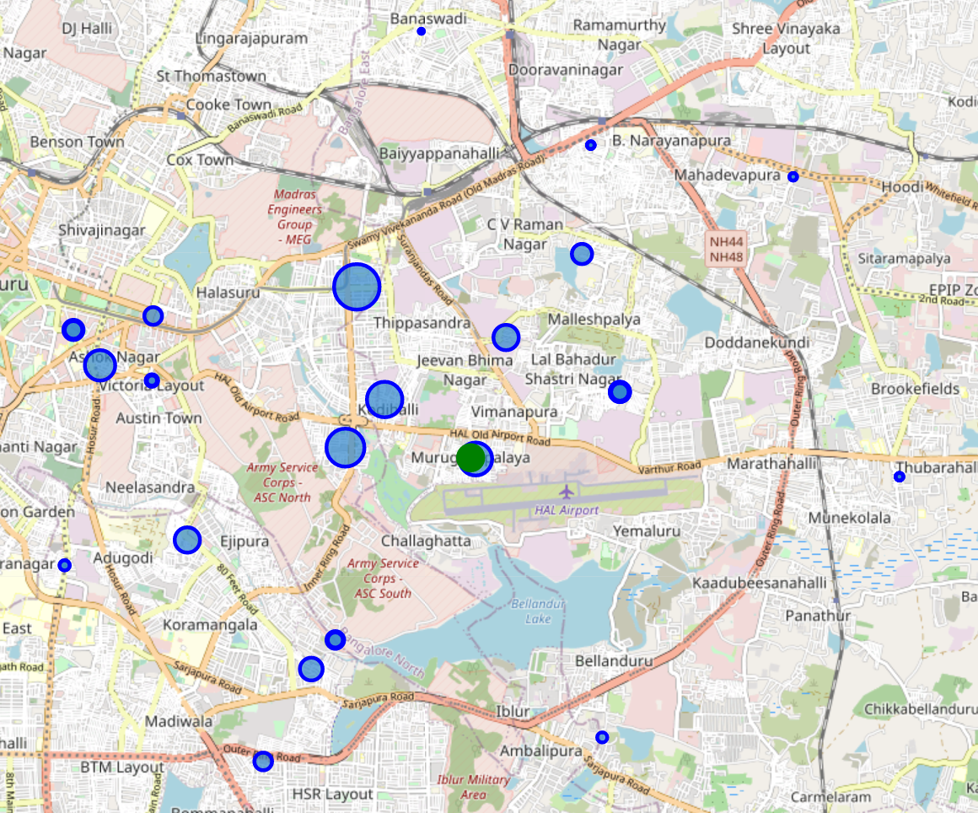

# Result

Based on the 3 underlying criteria’s of proximity, facilities and affordability, we’ve created a table to to rank the different neighbourhoods in Bangalore according to a custom metric which takes into account user defined weightages. The result table is as follows

# Observation and Recommendation

Our analysis shows that there are plenty of localities near the office within the user’s threshold. Based on the nearby venues data and taking into account the rent, Indira Nagar seems to be the most obvious choice to go for a renting place based on the weightages given by the user.

If the user doesn’t find any suitable renting place in Indiranagar he can go for other localities which are number 2, 3, 4 on the list, namely Domlur, Vimapura or HAL Second Stage.

There are some localities in the data whose rent data was not available as the data source for gathering the pin code vs locality data was different from source of getting rent data.

Some datapoints which had spelling difference or extra space were manually corrected to match with that of pin code data

Also, with respect to ranking of given locality based on the user preferred venues, the calculation or ranking could have been done in multiple ways, I chose a simple raking system. We could’ve used cluster analysis to get the difference of each locality with respect to the user preferred criteria.

# Conclusion

Purpose of this project was to identify areas most suitable for renting options keeping in mind different criteria and make it easier for the user to focus his search in only those areas. Instead of manually visiting all the places shown by real-estate broker, he can reject them beforehand based on our analysis. We had also made a provision of capturing his interest and make sure the selected area has ample facility, something which might be overlooked during actual decision

Final decision on area will be made by stakeholders based on specific characteristics of localities and locations, taking into consideration additional factors like proximity and affordability of the locality